**TOURIST GUIDE (DILLIMATE)**

PROJECT REPORT

(KCA451)

Submitted in Partial Fulfilment for the award of the degree

of

**MASTER OF COMPUTER APPLICATIONS**

(M.C.A)

Submitted by

**DARSHIT CHAUDHARY**

Roll No. 2000380140013

Under the Supervision of

Mr **Abhay Kumar Ray**

(Professor)



**Department of Information Technology**

**Institute of Technology & Science**

Mohan Nagar, Ghaziabad-201007

(2020-2022)

[www.its.edu.in](http://www.its.edu.in)

**SELF-DECLARATION**

I **DARSHIT CHAUDHARY(Roll no.-2000380140013)**a student of MASTERS OF COMPUTER APPLICATION do hereby solemnly affirm and declare as under:

* That TOURIST GUIDE (DILLI MATE) is done by me in guidance of **Abhay Kumar Ray.**
* That I have created the project as per the College/ University’s rules and regulations.
* All information provided and work done is completely genuine and is not copied from any online or offline platform.
* That I or any of my known have not submitted this project to any other University or College.

**Thanking You,**

#### Acknowledgement

We take this opportunity to thank our teachers and friends who helped us throughout the project.

First and foremost I would like to thank my guide for the project (**PROF.** **ABHAY KUMAR RAY** **, DEPARTMENT OF IT**) for his valuable advice and time during development of project.

We would also like to thank Dr. Sunil Kumar Pandey, Director-IT for his constant support during the development of the project.

DARSHIT CHAUDHARY

Roll No. 2000380140013

**Certificate**

### This is to Certify that **Darshit Chaudhar**y (Roll no.-2000380140013) has carried out the project work presented in this report entitled “TOURIST GUIDE” for the award of Masters of Computer Application from Institute of Technology & Science, Mohan Nagar, Ghaziabad, under my supervision. The report embodies result of original work and studies carried out by Student himself and the contents of the report do not form the basis for the award of any other degree to the candidate or to anybody else.

Date: 12 May, 2022 (PROF. Abhay Kumar Ray)

Institute Of Technology & Science

Mohan Nagar, Ghaziabad

INDEX

Chapter 1: Introduction

* 1. Overview & Problem Statement
  2. Purpose
  3. Scope
  4. Tools Used
  5. Methodology used
  6. Technology used

Chapter 2: System Analysis

1. Identification of Need
2. Preliminary Investigation
3. Feasibility Study

Chapter 3: Means of Project

1. Hardware Requirement
2. Software Requirements

Chapter 4: Overall Description

4.1 Product Perspective

4.2 Software Interface

4.3 Hardware Interface

4.4 Communication Interface

4.5 Constraints

4.6 ER Diagram

4.7 Data Flow Diagrams

4.8 Database Design

Chapter 5: Specific Diagrams

5.1 Class Diagram

5.2 Use-Case Diagram

5.3 Activity Diagrams

5.4 Sequence Diagrams

Chapter 6: Product Features

6.1 Screen Shots

Chapter 7: Test Cases and Test Results

Chapter 8: Conclusion

Chapter 9: References

Chapter 10:Future Scope of the Project

10.1 Further Enhancement of the Project

Chapter-11 Bibliography

**ABSTRACT**

This project presents the development of the Tourist Guide, a location-based tourist guide application for the outdoor environment. Our focus for this project is on software support for location-based applications; we are not just interested in the location but also other elements of the user's context, such as buildings in view, attractions and equipment nearby, such as hotels, pharmacy and restaurants. In this paper we will describe the Tourist Guide system and discuss the processes involved in the development of this application.

**Chapter-1: Introduction**

* 1. Overview & Problem Statement

**“**Tourist guide” is a major project that is prepared under the guidance of Prof. Abhay Kumar Ray, Out of several topics we choose this topic after analyzing the existing systems which doesn’t provide the tourist a complete package for their trips and tour.

The existing websites that we have currently does show options for the travelers but isn’t a fulfilling enough. Well normally, the tourists or basically any person with a ‘fish out of water’ tag on their back, had either to rely on the old timer ways to get to their destination in a foreign place, by asking for directions or asking the officials or even if they have a GPS system or any other location guide software on their devices they would still be running a constant fear of falling into Single Point Failure whenever the servers went down, which they will at one point or other.

Though our project tourist guide that me named as DilliMate, will be a one stop destination for all the tourists out there to get numerous options at single website by just one signup.

1.2 Purpose

The aim of this document is to describe the Project’s purpose. This document contains the functional, behavioral and non-functional requirements of the project and it also contains the guidelines for system engineers and designers to start working the project.

## 1.3 Project Scope

The topic of our project is Tourist Guide for Delhi. This Tourist Guide website will help to make tourist experience better and memorable of handy facilities at a single place.

This website with help users to know their nearby hotel and to select as per their convenience It’ll help the tourist vloggers and bloggers to explore amazing location Delicacies via accessing a single platform.

It also includes healthcare section which help the user in case of emergency we’ve also included cab & guide facility in order to get the full tour of city.

1.4 Tools Used

As we all are aware of the fact that a good project is a project that has an effective front end and the good back end in order to have a good service. A lot of tools are required in order to make a successful project here is the description of the tools, the software and the hardware that are used in order to make this project.

* FRONT END COVERAGE

Front-end" typically means the parts of the project a user interacts with--such as the graphical user interface or command line. It's a vague term, there isn't an exact definition.

Here we are going to discuss about the various tools and software(s) that we have used to make our graphic interfaces and front end.

* Eclipse IDE

Eclipse is an integrated development environment (IDE) used in computer programming.[5] It contains a base workspace and an extensible plug-in system for customizing the environment. Eclipse is written mostly in Java and its primary use is for developing Java applications, but it may also be used to develop applications in other programming languages via plug-ins, including Ada, ABAP, C, C++, C#, Clojure, COBOL, D, Erlang, Fortran, Groovy, Haskell, JavaScript, Julia,[6] Lasso, Lua, NATURAL, Perl, PHP, Prolog, Python, R, Ruby (including Ruby on Rails framework), Rust, Scala, and Scheme. It can also be used to develop documents with LaTeX (via a TeXlipse plug-in) and packages for the software Mathematica.

Development environments include the Eclipse Java development tools (JDT) for Java and Scala, Eclipse CDT for C/C++, and Eclipse PDT for PHP, among others.

* APACHE TOMCAT

Apache Tomcat is the world's most widely used web application server, with over one million downloads per month and over 70% penetration in the enterprise datacenter. Apache Tomcat is used to power everything from simple one server sites to large enterprise networks.

The following is a collection of Apache Tomcat resources that will help you identify, monitor, troubleshoot, and resolve common problems with Apache Tomcat.

* HYPER TEXT MARKUP LANGUAGE (HTML)

**Hypertext Markup Language** (**HTML**) is the standard [markup language](https://en.wikipedia.org/wiki/Markup_language" \o "Markup language) for creating [web pages](https://en.wikipedia.org/wiki/Web_page" \o "Web page) and [web applications](https://en.wikipedia.org/wiki/Web_application" \o "Web application). With [Cascading Style Sheets](https://en.wikipedia.org/wiki/Cascading_Style_Sheets" \o "Cascading Style Sheets) (CSS) and [JavaScript](https://en.wikipedia.org/wiki/JavaScript" \o "JavaScript) it forms a triad of cornerstone technologies for the [World Wide Web](https://en.wikipedia.org/wiki/World_Wide_Web" \o "World Wide Web). [Web browsers](https://en.wikipedia.org/wiki/Web_browser" \o "Web browser) receive HTML documents from a [web server](https://en.wikipedia.org/wiki/Web_server" \o "Web server) or from local storage and render them into multimedia web pages. HTML describes the structure of a web page [semantically](https://en.wikipedia.org/wiki/Semantic_Web" \o "Semantic Web) and originally included cues for the appearance of the document.

[HTML elements](https://en.wikipedia.org/wiki/HTML_element" \o "HTML element) are the building blocks of HTML pages. With HTML constructs, [images](https://en.wikipedia.org/wiki/HTML_element" \l "Images_and_objects" \o "HTML element) and other objects, such as forms, may be embedded into the rendered page. It provides a means to create [structured documents](https://en.wikipedia.org/wiki/Structured_document" \o "Structured document) by denoting structural [semantics](https://en.wikipedia.org/wiki/Semantics" \o "Semantics) for text such as headings, paragraphs, lists, [links](https://en.wikipedia.org/wiki/Hyperlink" \o "Hyperlink), quotes and other items. HTML elements are delineated by *tags*, written using [angle brackets](https://en.wikipedia.org/wiki/Bracket" \l "Angle_brackets" \o "Bracket). Tags such as <img /> and <input /> introduce content into the page directly. Others such as <p>...</p> surround and provide information about document text and may include other tags as sub-elements. Browsers do not display the HTML tags, but use them to interpret the content of the page

* CASCADING STYLE SHEETS (CSS)

Cascading Style Sheets (CSS) is a style sheet language used for describing the presentation of a document written in a markup language. Although most often used to set the visual style of web pages and user interfaces written in HTML and XHTML, the language can be applied to any XML document, including plain XML, SVG and XUL, and is applicable to rendering in speech, or on other media. Along with HTML and JavaScript, CSS is a cornerstone technology used by most websites to create visually engaging webpages, user interfaces for web applications, and user interfaces for many mobile applications.

CSS is designed primarily to enable the separation of presentation and content, including aspects such as the layout, colors, and fonts. This separation can improve content accessibility, provide more flexibility and control in the specification of presentation characteristics, enable multiple HTML pages to share formatting by specifying the relevant CSS in a separate .css file, and reduce complexity and repetition in the structural content.

* BACKEND COVERAGE

**Back end**is the module to which all the input of the front end goes or from where all the output comes to front end after processing through various algorithms. This may include your processing layer, database layer etc.Back-end" means the parts that do the work, but the user is unaware of or cannot see. Databases, services, etc. Think of it like a restaurant where you can't see the kitchen. As a customer you see the front-end--the decorations, menus, and wait-staff. Meanwhile the kitchen and stockroom are out of view

* MY SQL SERVER

MySQL (officially pronounced as "My S-Q-L" is an open-source relational database management system(RDBMS) Its name is a combination of "My", the name of co-founder Wideness’s daughter, and "SQL", the abbreviation for Structured Query Language. The MySQL development project has made its source code available under the terms of the GNU General Public License, as well as under a variety of proprietary agreements. MySQL was owned and sponsored by a single for-profit firm, the Swedish company MySQL AB, now owned by Oracle Corporation. For proprietary use, several paid editions are available, and offer additional functionality.

MySQL is a central component of the LAMP open-source web application software stack (and other "AMP" stacks). LAMP is an acronym for "Linux, Apache, MySQL, Perl/PHP/Python". Applications that use the MySQL database include: TYPO3, MODx, Joomla, WordPress, phpBB, MyBB, and Drupal. MySQL is also used in many high-profile, large-scale websites, including Google (though not for searches), Facebook, Twitter, Flickr, and YouTube.

The project of MySQL was started in 1979, when MySQL's inventor, Michael Widenius developed an in-house database tool called UNIREG for managing databases. After that UNIREG has been rewritten in several different languages and extended to handle big databases. After some time Michael Widenius contacted David Hughes, the author of mSQL, to see if Hughes would be interested in connecting mSQL to UNIREG's B+ ISAM handler to provide indexing to mSQL. That's the way MySQL came in existence.

* 1. Methodology used

# Prototype Model

The prototype model requires that before carrying out the development of actual software, a working prototype of the system should be built. A prototype is a toy implementation of the system. A prototype usually turns out to be a very crude version of the actual system, possible exhibiting limited functional capabilities, low reliability, and inefficient performance as compared to actual software. In many instances, the client only has a general view of what is expected from the software product. In such a scenario where there is an absence of detailed information regarding the input to the system, the processing needs, and the output requirement, the prototyping model may be employed.

## Steps of Prototype Model

1. Requirement Gathering and Analyst
2. Quick Decision
3. Build a Prototype
4. Assessment or User Evaluation
5. Prototype Refinement
6. Engineer Product

## Advantage of Prototype Model

1. Reduce the risk of incorrect user requirement
2. Good where requirement are changing/uncommitted
3. Regular visible process aids management
4. Support early product marketing
5. Reduce Maintenance cost.
6. Errors can be detected much earlier as the system is made side by side.
   1. Technology used

* **Browsers**

Browsers are the interpreters of the web. They request information and then when they receive it, they show us on the page in a format we can see and understand.

[Google Chrome](https://www.google.com/chrome/) - Currently, the most popular browser brought to you by Google

[Firefox](https://www.mozilla.org/en-US/firefox/new/) - Open-source browser supported by the Mozilla Foundation

[Internet Explorer](http://windows.microsoft.com/en-us/internet-explorer/download-ie) - Microsoft’s browser. You will most often hear web developers complain about this one.

* **HTML**

[HTML](https://developer.mozilla.org/en-US/docs/Web/HTML) is a markup language. It provides the structure of a website so that web browsers know what to show.

* **CSS**

[CSS](https://developer.mozilla.org/en-US/docs/Web/CSS) is a Cascading Style Sheet. CSS let’s web designers change colors, fonts, animations, and transitions on the web. They make the web look good.

* **Programming Languages**

Programming languages are ways to communicate to computers and tell them what to do. There are many different programming languages just like there are many different lingual languages (English, Spanish, French, Chinese, etc). One is not better than the other. Developers typically are just proficient at a couple so they promote those more than others. Below are just some of the languages and links to their homepages.

* **[Javascript](https://developer.mozilla.org/en-US/docs/Web/JavaScript)**

It is used by all web browsers, Meteor, and lots of other frameworks

* **Databases**

Databases are where all your data is stored. It’s like a bunch of filing cabinets with folders filled with files. Databases come mainly in two flavors: SQL and NoSQL. SQL provides more structure which helps with making sure all the data is correct and validated. NoSQL provides a lot of flexibility for building and maintaining applications.

* **[MySQL](http://www.mysql.com/)** - is another popular open-sourced SQL database. MySQL is used in Wordpress websites.

Client (or Client-side)

A client is one user of an application. It’s you and me when we visit [http://google.com](http://google.com/). Client’s can be desktop computers, tablets, or mobile devices. There are typically multiple clients interacting with the same application stored on a server.

* **Server (or Server-side)**

A server is where the application code is typically stored. Requests are made to the server from clients, and the server will gather the appropriate information and respond to those requests.

**CHAPTER 2: System Analysis**

Systems analysis is the process of examining a business situation for the purpose of developing a system solution to a problem or devising improvements to such a situation. Before the development of any system can begin, a project proposal is prepared by the users of the potential system and/or by systems analysts and submitted to an appropriate managerial structure within organization.

1. **Identification of Need**

Although people can get some general information regarding traveling over the internet, it is sometimes problematic for the newcomers in a place to get familiar with the new environment. Basically, they face difficulties in communicating and finding proper routing information and associated costs for distinct routes.

Now a days people have been moved so much into the modern technology that they really want an intelligent living environment along with intelligent objects which contain powerful infrastructure with the most desired features.

1. **Preliminary Investigation**

While making this project we have gone through a lot of study. Requirement gathering, going through the survey understanding the drawbacks in the existing system and finding out the features for the proposed system.

1. **Feasibility Study**

A feasibility study is used to determine the viability of an idea, such as ensuring a project is legally and technically feasible as well as economically justifiable. It tells us whether a project is worth the investment—in some cases, a project may not be doable. There can be many reasons for this, including requiring too many resources, which not only prevents those resources from performing other tasks but also may cost more than an organization would earn back by taking on a project that isn’t profitable.

* **Economical Feasibility**

This is a very important aspect to be considered while developing a project. We decided the technology based on minimum possible cost factor. In the economical feasibility, the development cost in creating the system is evaluated against the ultimate benefit derived from the new systems. Financial benefits must equal or exceed the costs.

The system is economically feasible. It does not require any addition hardware or software. There is nominal expenditure and economical feasibility for certain.

* **Technical feasibility**

This included the study of function, performance and constraints that may affect the ability to achieve an acceptable system. For this feasibility study, we studied complete functionality to be provided in the system, as described in the System Requirement Specification (SRS), and checked if everything was possible using different type of frontend and backend Platform.

Does the necessary technology exist to do what is suggested?

Do the proposed equipment have the technical capacity to hold the data required to use the new system?

Will the proposed system provide adequate response to inquiries, regardless of the number or location of users?

Can the system be upgraded if developed?

Are there technical guarantees of accuracy, reliability, ease of access and data security?

Earlier no system existed to cater to the needs of ‘Secure Infrastructure Implementation System’. The current system developed is technically feasible. It is a web based user interface. Thus it provides an easy access to the users. The database’s purpose is to create, establish and maintain a workflow among various entities in order to facilitate all concerned users in their various capacities or roles. Permission to the users would be granted based on the roles specified. Therefore, it provides the technical guarantee of accuracy, reliability and security.

* **Operational feasibility**

No doubt the proposed system is fully GUI based that is very user friendly inputs to be taken all self-explanatory even to a layman As far our study is concerned the clients are comfortable and happy as the system has cut down their loads and doing. Some of the important issues raised are to test the operational feasibility of a project includes the following: –

* Is there sufficient support for the management from the users?
* Will the system be used and work properly if it is being developed and implemented?
* Will there be any resistance from the user that will undermine the possible application benefits?

This system is targeted to be in accordance with the above-mentioned issues. Beforehand, the management issues and user requirements have been taken into consideration. So there is no question of resistance from the users that can undermine the possible application benefits.

The well-planned design would ensure the optimal utilization of the computer resources and would help in the improvement of performance status.

**Chapter 3: Means of Project**

1. **Hardware Requirement**

Hardware means the devices or the requirements that we can see, feel or touch such as our pc, mobile, etc. Given below are the hardware requirements that are to access this project.

|  |  |
| --- | --- |
| **Name of Component** | **Specification** |
| **Processor** | Pentium III 630MHZ |
| **RAM** | 128MB |
| **Hard disk** | 20 GB |
| **Monitor** | 15” colour monitor |
| **Keyboard** | 122 keys |

**3.2. Software Requirements**

* **Computer software**, or simply **software**, is a part of a [computer system](https://en.wikipedia.org/wiki/Computer_system" \o "Computer system) that consists of [data](https://en.wikipedia.org/wiki/Data_(computing)" \o "Data (computing)) or computer instructions, in contrast to the [physical hardware](https://en.wikipedia.org/wiki/Computer_hardware" \o "Computer hardware) from which the system is built. In [computer science](https://en.wikipedia.org/wiki/Computer_science" \o "Computer science) and [software engineering](https://en.wikipedia.org/wiki/Software_engineering" \o "Software engineering), computer software is all [information](https://en.wikipedia.org/wiki/Information" \o "Information) processed by [computer systems](https://en.wikipedia.org/wiki/Computer_system" \o "Computer system), [programs](https://en.wikipedia.org/wiki/Computer_program" \o "Computer program) and data. Computer software includes [computer programs](https://en.wikipedia.org/wiki/Computer_program" \o "Computer program), [libraries](https://en.wikipedia.org/wiki/Library_(computing)" \o "Library (computing)) and related non-executable [data](https://en.wikipedia.org/wiki/Data_(computing)" \o "Data (computing)), such as [online documentation](https://en.wikipedia.org/wiki/Software_documentation" \o "Software documentation) or [digital media](https://en.wikipedia.org/wiki/Digital_media" \o "Digital media). Computer hardware and software require each other and neither can be realistically used on its own.

Here are the software requirements of the project

|  |  |
| --- | --- |
| **Name of Component** | **Specification** |
|  |  |
| **Operating System** | Window 98, Window XP,Window 7,8 & 10 |
| **Language** | HTML,JAVASRIPT,JSP,JAVA, JAVA 2 Runtime Environment |
| **Database** | MySQL Server |
| **Browser** | MOZILLA,OPERA,CHROME |
| **Web Server** | Apache Tomcat |
| **Software Development Kit** | Java JDK 1.7 or above |
| **Software Language Enable JSP(Java server page)** | |
| **Database GDBC Driver MySQL Jconnector** | |

**Chapter 4: Overall Description**

**4.1 Product Perspective**

With the large of globalization, tourism also widely increases in nowadays. The

technology in tourism also increase and the tourist can find the tourism information on blogs, forums and websites and etc. However, the mobile tourist guided systems are more conveniently supported to user by their real time and location sensitive information.

Due to this fact, this system is proposed as the tourist guide information system for the mobile smart phone. The goal of this system is to provide the personalized access to tourism information at anytime from anywhere in Delhi. Users can get the detailed information of the nearest places from them. Users can also easily be guided to their interesting nearest places by the website.

The local information of Delhi city is stored in online server database. Since the system use the online server database, the database can easily be updated at anytime and anywhere.

**4.2 Software Interface**

MySQL Workbench is a unified visual tool for database architects, developers, and DBAs. MySQL Workbench provides data modeling, SQL development, and comprehensive administration tools for server configuration, user administration, backup, and much more. MySQL Workbench is available on Windows, Linux and Mac OS X. MySQL Workbench enables a DBA, developer, or data architect to visually design, model, generate, and manage databases. It includes everything a data modeler needs for creating complex ER models, forward and reverse engineering, and also delivers key features for performing difficult change management and documentation tasks that normally require much time and effort.

Spring Boot makes it easy to create stand-alone, production-grade Spring based Applications that you can "just run. Spring Boot is an open source Java-based framework used to create a micro Service. It is developed by Pivotal Team and is used to build stand-alone and production ready spring applications. This chapter will give you an introduction to Spring Boot and familiarizes you with its basic concepts

### 

### 4.3. Hardware Interfaces

Since the application must run over the internet, all the hardware shall require to connect internet will be hardware interface for the system. As for e.g. Modem, WAN – LAN, Ethernet Cross-Cable.

### 4.4 Communications Interfaces

The tourist guide system shall use the HTTP protocol for communication over the internet and for the intranet communication will be through TCP/IP protocol suite.

**4.5 Constraints**

With any project, there are [limitations and risks](https://www.pmi.org/learning/library/six-constraints-enhanced-model-project-control-7294" \t "_blank) that need to be addressed to ensure the project’s ultimate success. The three primary constraints that project managers should be familiar with are time, scope, and cost. These are frequently known as the triple constraints.

The triple constraints of project management

* **Time constraint :-**

The time constraint refers to the project’s schedule for completion, including the deadlines for each phase of the project, as well as the date for rollout of the final deliverable.

* **Scope constraint** :-

The scope of a project defines its specific goals, deliverables, features, and functions, in addition to the tasks required to complete the project.

* **Cost constraint :-**

The cost of the project, often dubbed the project’s budget, comprises all of the financial resources needed to complete the project on time, in its predetermined scope. Keep in mind that cost does not just mean money for materials — it encompasses costs for labor, vendors, quality control, and other factors, as well.

Let's look at each of the three constraints in detail

* **Time constraint :-**

When it comes to time constraints, proper scheduling is essential. According to the Project Management Body of Knowledge (PMBOK), the following steps should be taken for effective time management:

Planning: This includes defining the main goal(s) of the project team, how the team intends to achieve the goal(s), and the equipment and/or steps that will be taken to do so.

Scheduling: The project management team must plot out the realistic timeframe to complete each phase of the project.

Monitoring: This step occurs once the project is underway and requires the project team to analyze how the past stages of the project performed, noting trends and impacts on future plans, and communicating these findings to all relevant stakeholders.

Control: In the control step, the team must, upon communicating the results of each phase of the project, move forward accordingly. That means if things are running smoothly, the team must analyze the factors contributing to that positive outcome so that it can be continued and replicated. If there has been a derailment, the team must know how and why the derailment occurred and correct it for future actions.

A Gantt chart can help to visualize the project timeline and whether they are tracking to the proper constraints.

* **Scope constraint:-**

Defined upfront, the scope of the project should be clearly and regularly communicated to all stakeholders to ensure that “scope creep” — the term used when changes are made to the scope mid-project, without the same levels of control — is avoided. To keep the scope in check, you can:

Provide clear documentation of the full project scope at the beginning of the project, including all requirements.

Set up a process for managing any changes, so if someone proposes a change, there is a controlled system in place for how that change will be reviewed, approved or rejected, and implemented if applicable.

Communicate the scope clearly and frequently with stakeholders.

* **Cost constraint :-**

A project’s budget includes both fixed and variable costs, including materials, permits, labor, and the financial impact of team members working on the project. A few of the ways to estimate the cost of a project include:

Historical data: Looking at what similar projects cost in the recent past

Resources: Estimating the rate of cost for goods and labor.

Parametric: Comparing historical data with updated, relevant variables

Vendor bid: Averaging the total charge of several solid vendor bids

Effective cost control is paramount to the success of the project.

**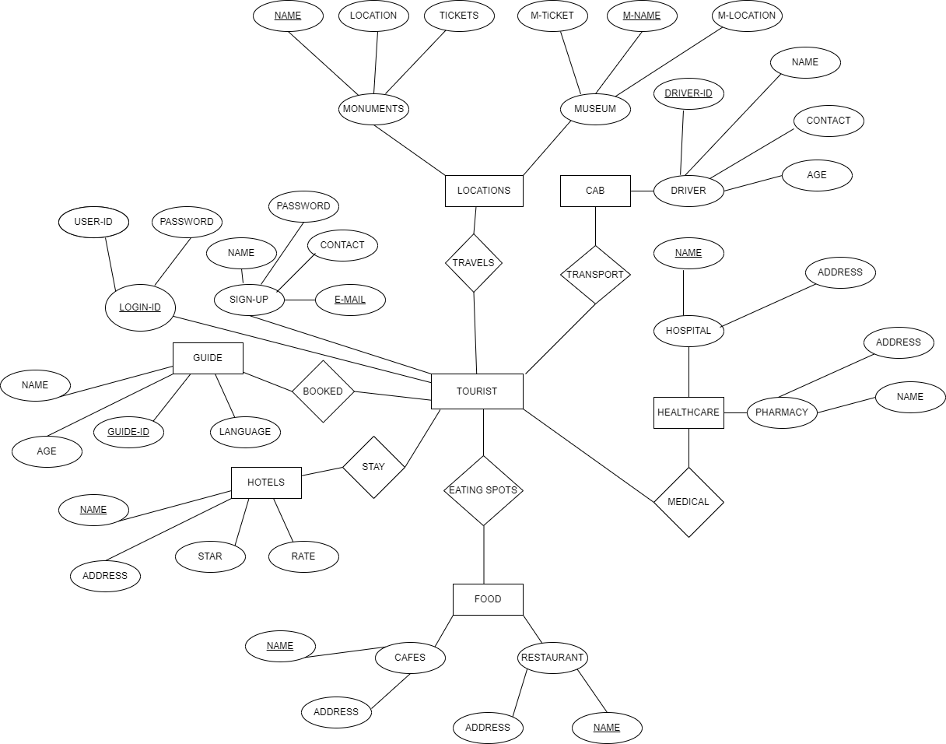4.6 ER Diagram**

**4.7 Data Flow Diagram**

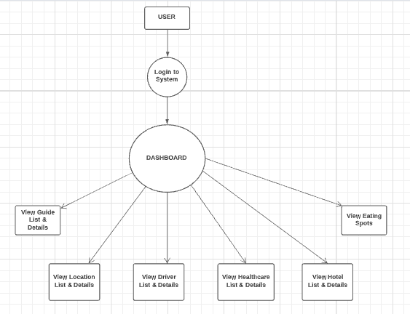

**4.8 Database Design**

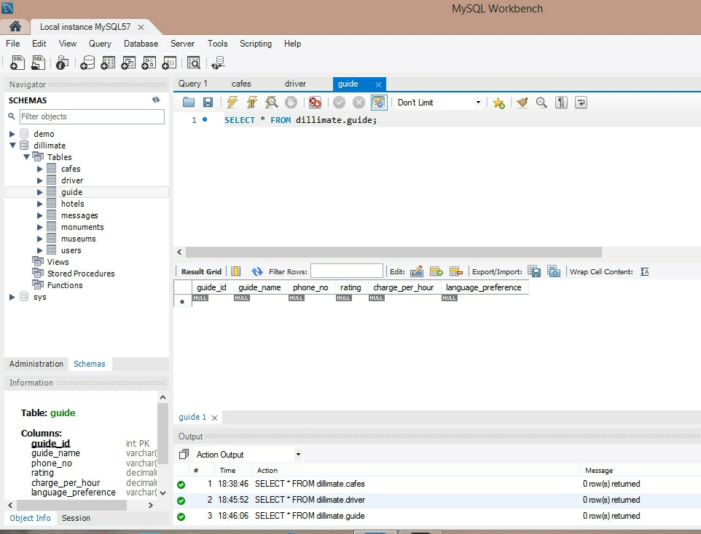

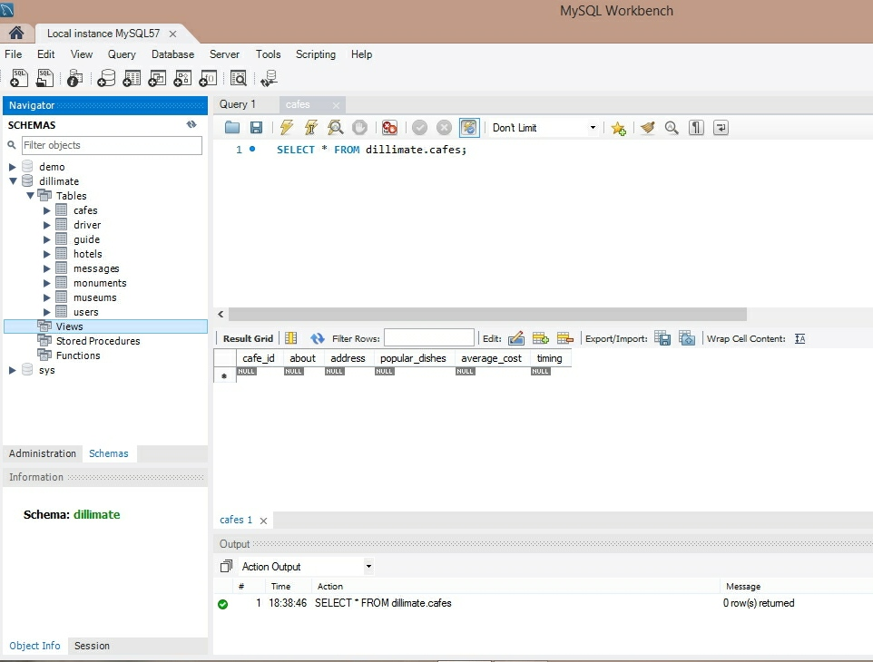

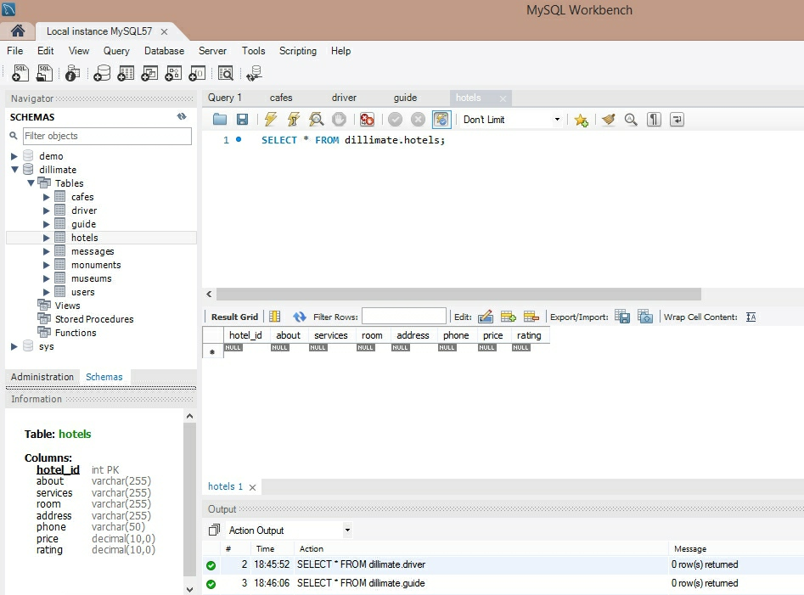

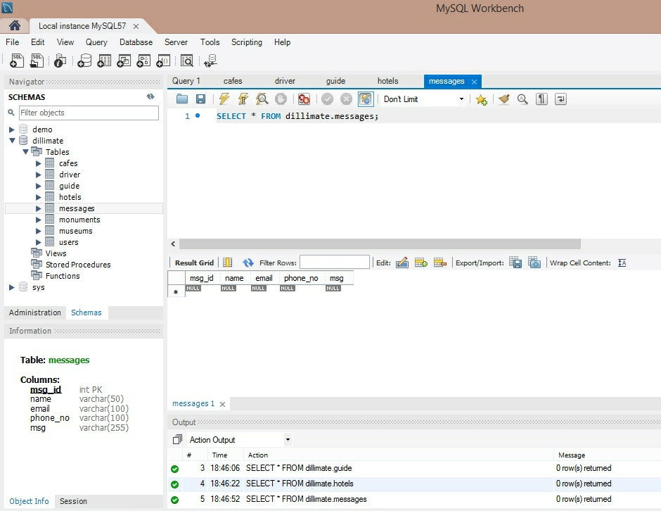

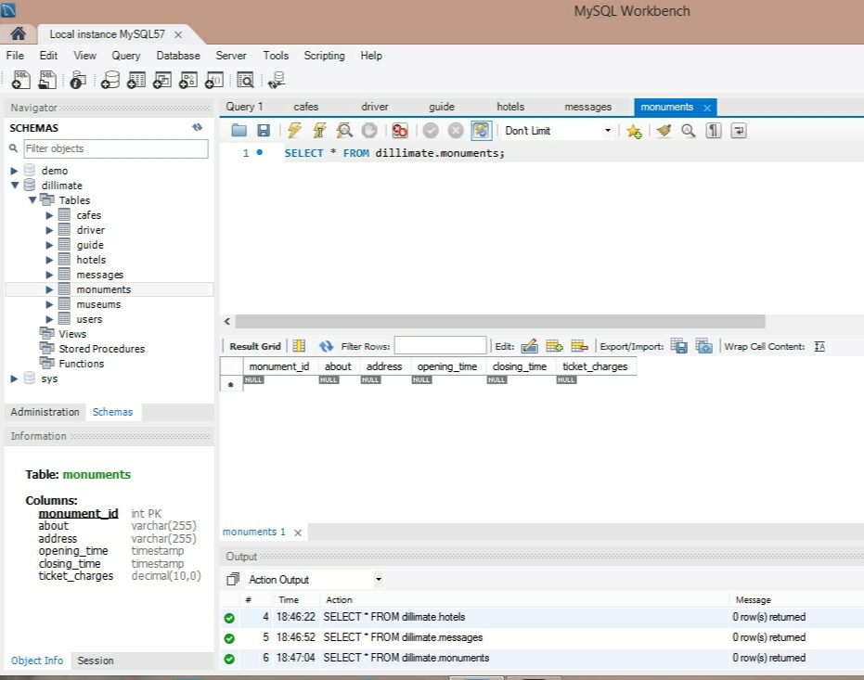

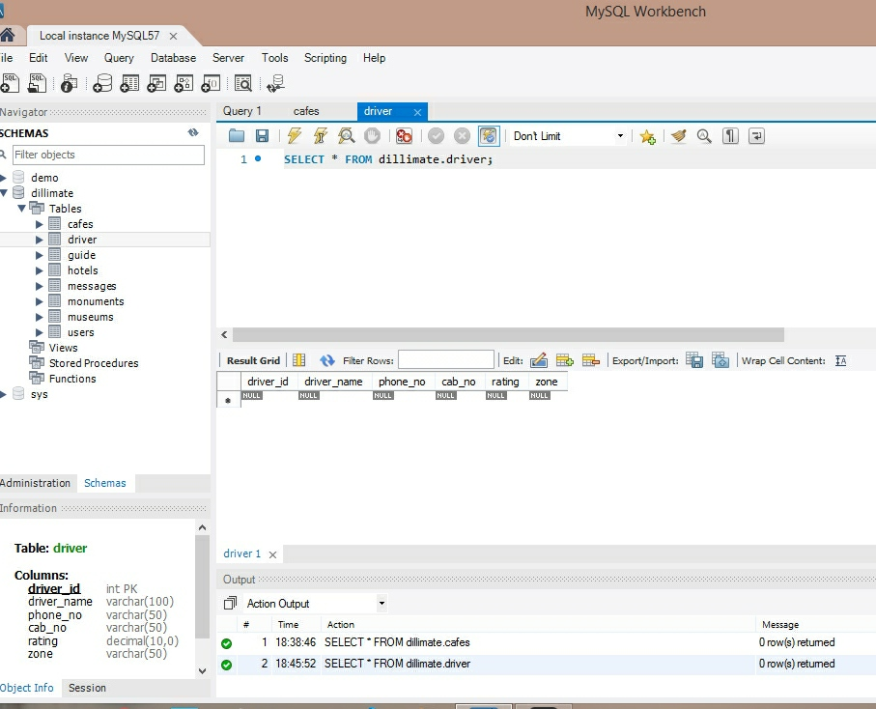

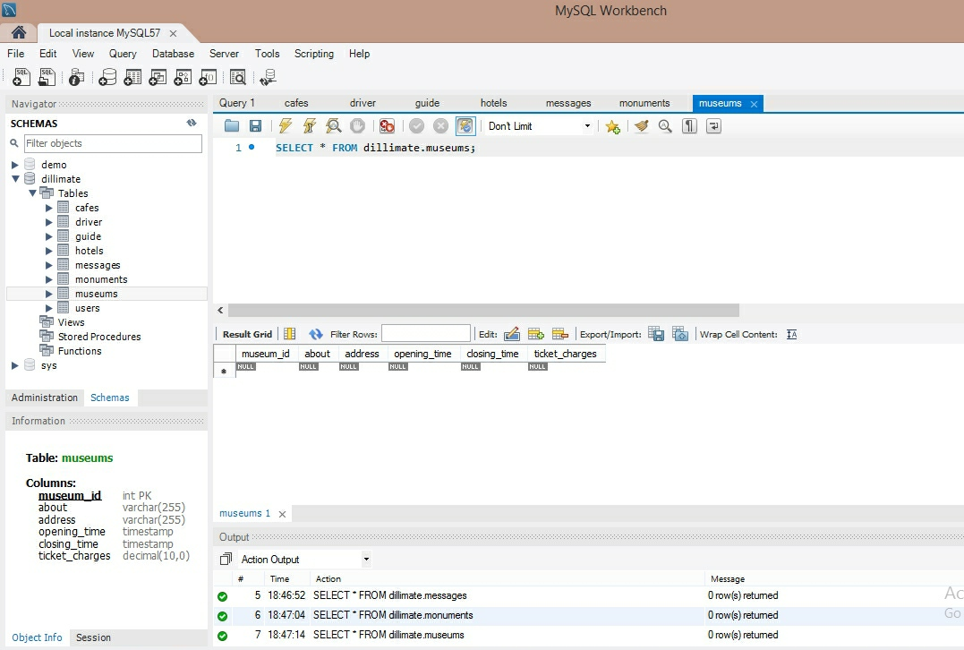

**Chapter 5: Specific Diagrams**

**5.1 Class Diagram**

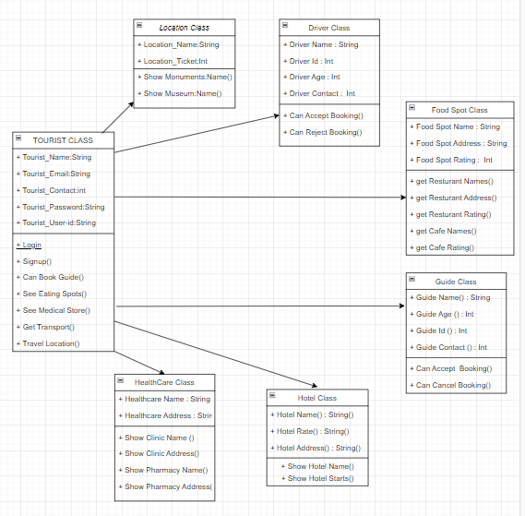

**5.2 Use-Case Diagram**

**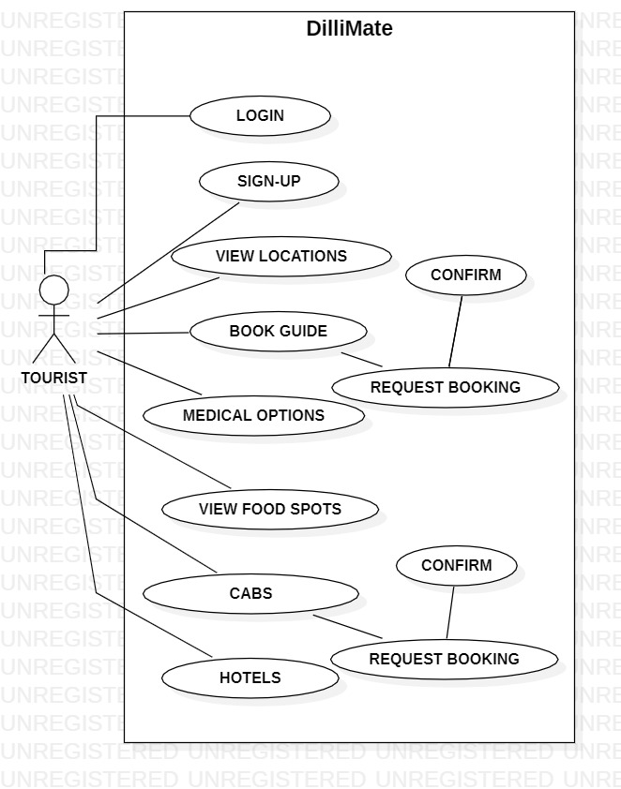**

**5.3 Activity Diagrams**

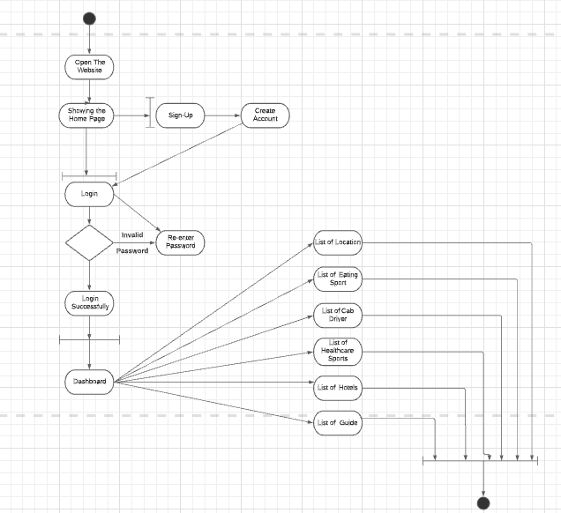

**5.4 Sequence Diagrams**

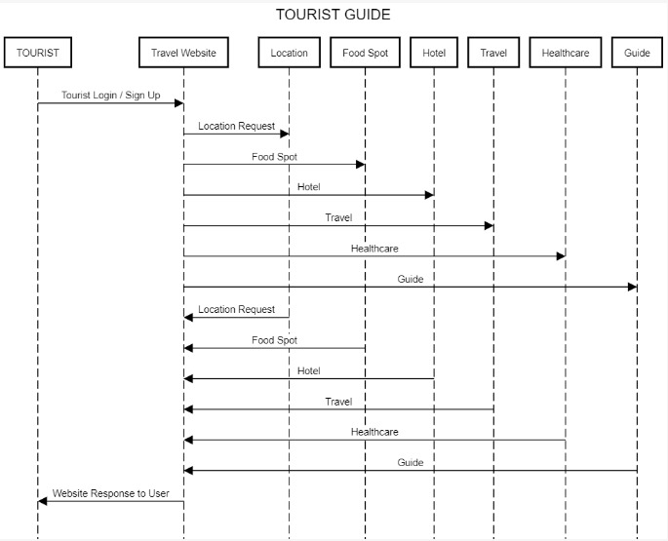

**Chapter 6: Product Features**

The main idea of this thesis was to design a system that will run on most of phones and palms and will be helpful when visiting some new places and cities. criteria should be simple and natural, like for example: a list of museums, the most famous historical objects, restaurants to visit, constraints to travel by bus and by walking. The system should find a path that fulfills those criteria, show it on screen, show names of objects, some short descriptions and photos of them and possible entrance costs. It should also be able to estimate time needed to travel from one object to the next and if it is possible, advise which bus line or other public means of transport may be used. It should be helpful for people that want to visit a city without having much information about it. Paths that are output of this system are only a proposition for trip.

* Registered user gets the recommendation of the places of their preferences.
* They can find the places using this system.
* User can easily view the place on website with its description, image and address.
* The system also provides one food place in the results.
* System GUI is easy to use.

**6.1 Screen Shots**

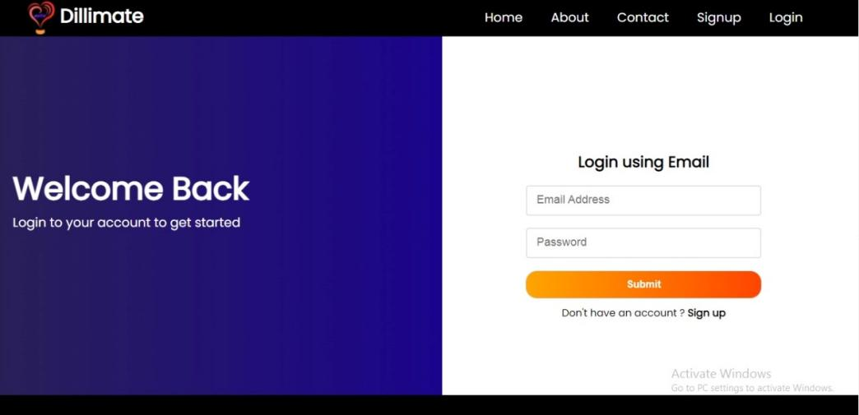

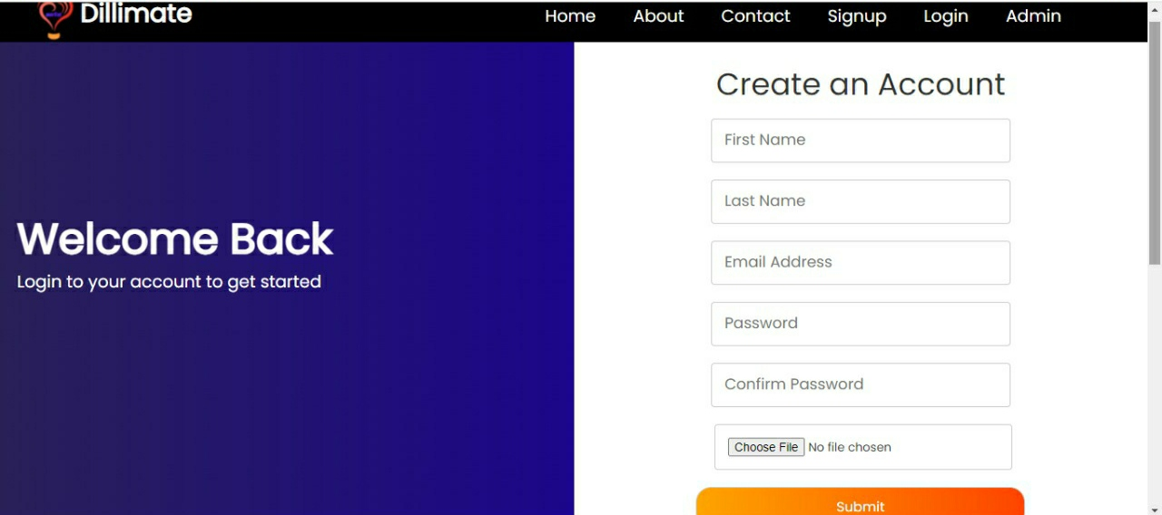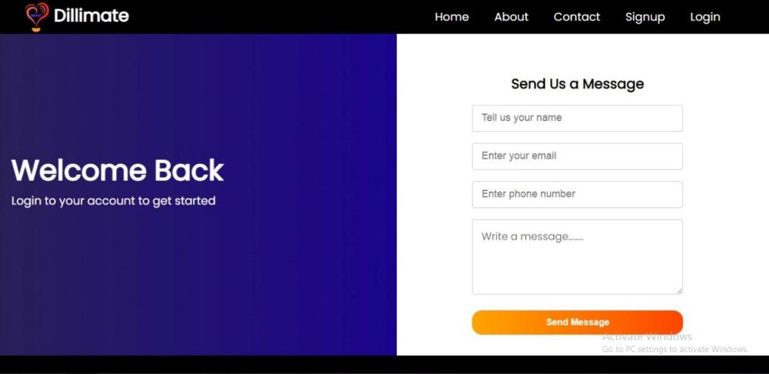

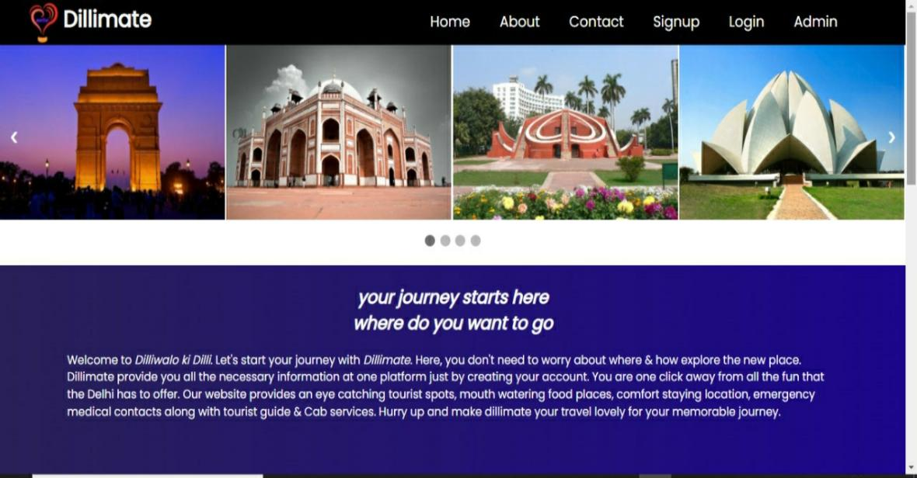

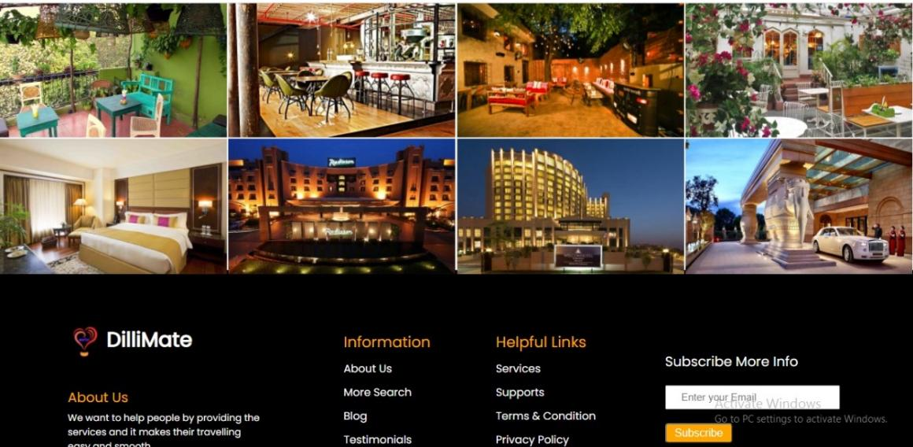

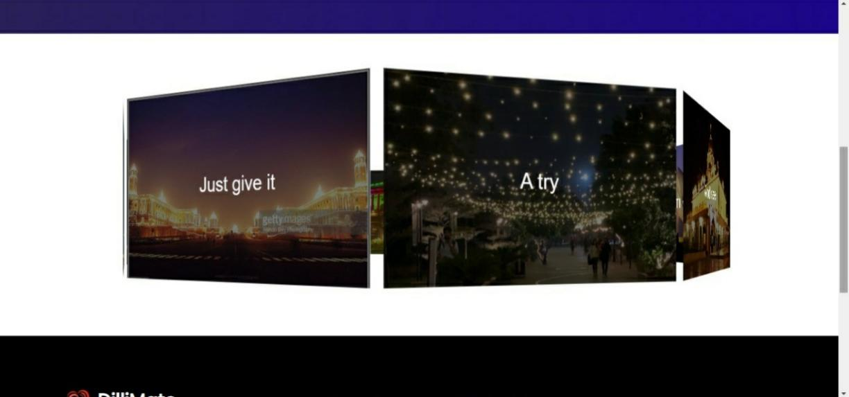

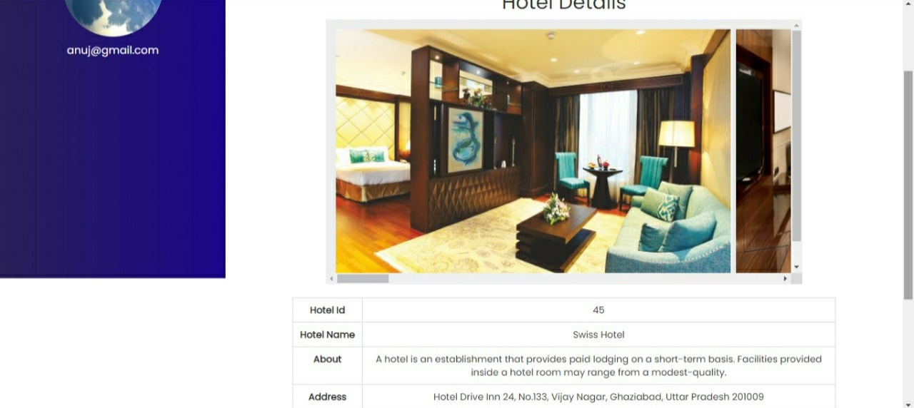

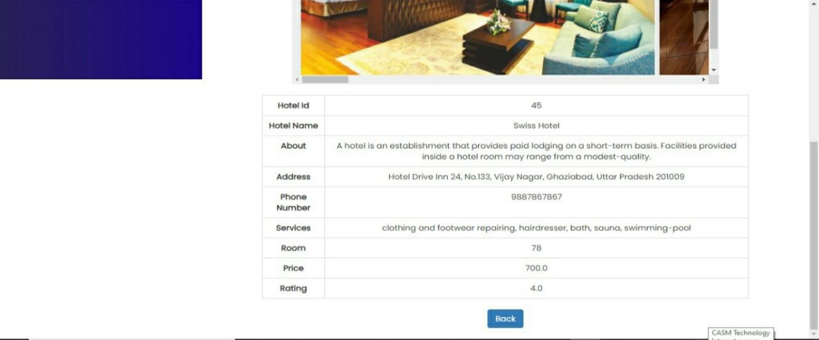

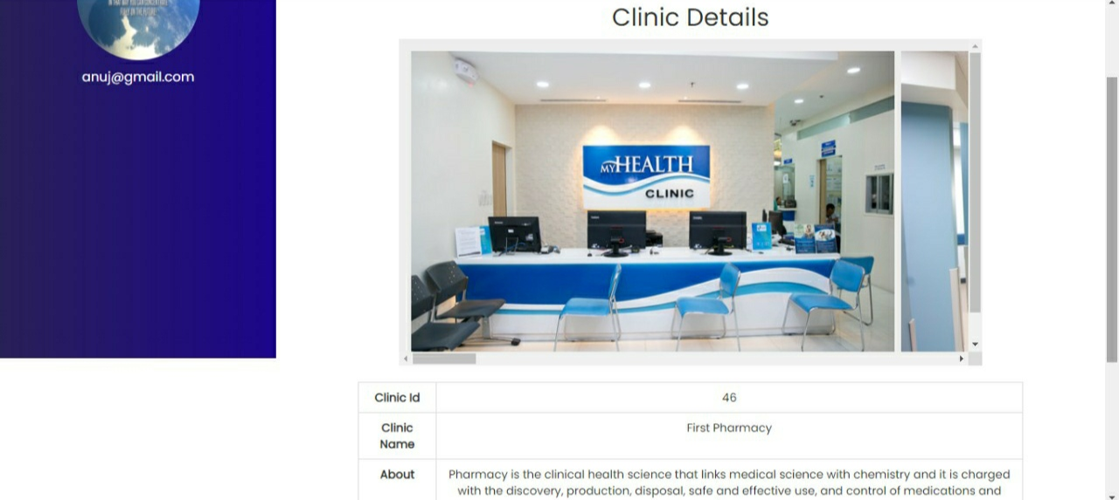

**Chapter 7: Test Cases and Test Results**

### Test Cases – Login Page

| **Sr. No.** | **Test Cases** | **Type- Negative/ Positive Test Case** |
| --- | --- | --- |
| 1 | Verify if a user will be able to login with a valid username and valid password. | Positive |
| 2 | Verify if a user cannot login with a valid username and an invalid password. | Negative |
| 3 | Verify the login page for both, when the field is blank and Submit button is clicked. | Negative |
| 4 | Verify if the data in password field is either visible as asterisk or bullet signs. | Positive |
| 5 | Verify if a user is able to login with a new password only after he/she has changed the password. | Positive |
| 6 | Verify if the login page allows to log in simultaneously with different credentials in a different browser. | Positive |
| 7 | Verify if the ‘Enter’ key of the keyboard is working correctly on the login page. | Positive |

### Test Cases – Signup

| **Sr. No.** | **Test Cases** | **Type- Negative/ Positive Test Case** |
| --- | --- | --- |
| 1 | Check user should Register by filling all the required fields | Positive |
| 2 | Check the Email text field that has an Email address without @ symbol. • Check the Email text field that has a random string instead of a real email. • Check the Email text field that has @ symbol written in words. • Check the Email text field that has a missing dot in the email address. | Positive |
| 3 | Verify if the password required rules are not satisfied in the password | Positive |
| 4 | Check the required fields by not filling any data | Negative |
| 5 | Check all the text boxes, radio buttons, buttons, etc. | Positive |

**Chapter 8: Conclusion**

Keeping travellers need in consideration and the current trend, we have developed our Tourist Guide Application. The application is able to meet most of the requirements that is commonly asked by the travellers, Besides, the simplicity of using the application has been maintained. The app can be helpful for travellers who are the newcomers to the Delhi.

**Chapter 9: References**

* <https://www.eclipse.org/>
* <https://www.google.com/search?q=documentation+for+tourist+guide+project&ei=qHPiYbGzC8G0mgfx0Jj4Cw&oq=documentation+for+tourist+guide&gs_lcp=Cgdnd3Mtd2l6EAEYADIICCEQFhAdEB4yCAghEBYQHRAeMggIIRAWEB0QHjIICCEQFhAdEB46BwgAEEcQsAM6BQgAEIAEOgYIABAWEB46CAgAEBYQChAeOgYIABANEB46CAgAEA0QChAeOgQIIRAKSgQIQRgASgQIRhgAUP8BWNA9YMlLaARwAngAgAG_AYgB4ROSAQQwLjE3mAEAoAEByAEIwAEB&sclient=gws-wiz>
* <https://www.researchgate.net/publication/281490309_Android_Application_Travel_Guide>
* <https://www.google.com/search?q=analysis+for+tourist+guide&gs_ivs=1>
* <https://nevonprojects.com/intelligent-tourist-guide/>

**Chapter 10: Future Scope of the Project**

**10.1 Further Enhancement of the Project**

Based on the current limitations of our project, there can be some recommendations to

improve the features of our app in order to make it more user friendly, efficient and effective

as well.

* **Real Time Interactive Conversation:** The conversation in hotels, buses and

restaurants are to be real time interactive through instant language translations.

* **GPS Location Tracker**: Instead of giving user’s current location to the map, the

User’s location will be automatically followed by GPS location tracker which will make the app more powerful and systematic.

* **More Detailed Routing Information:** More details of routing information nearby

areas in the city can be provided to the user.

* **Whole Country Coverage:** As we are using Google’s map for locating user’s

destination and finding the route information, this app can be implemented for the entire country coverage.